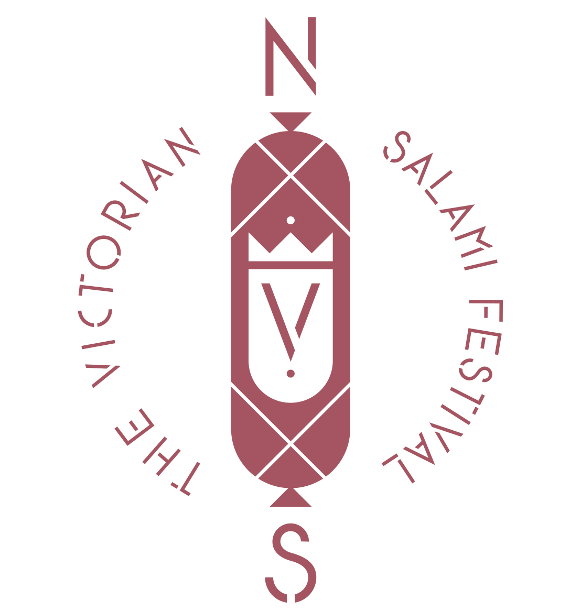
ENTRY FORM
THE VICTORIAN SALAMI FESTIVAL 2021
HOW TO ENTER
If you think you have what it takes to make the perfect salami and you wish to enter in this year’s Victorian Salami Festival, follow these 3 simple steps.
Step 1:
Fill out the entry form and email to:

Dal Zotto Wines: www.dalzotto.com.au
Phone: (03) 5729 8321
Email: info@dalzotto.com.au
The Meat Room: www.themeatroom.com.au
Phone: 0419 242 815
Email: info@themeatroom.com.au

Note: You can enter as a team or an individual
Please be sure to correctly indicate the style of salami you are entering. If you do not indicate a style, one of our “Salami Specialists” will put your salami into the relevant section.
Step 2: The Important Part!
Deliver your 200grms of salami to the relevant address by September 18th, 2021.
Step 3: Purchase your ticket to the Victorian Salami Festival
Winners will be announced at the 2021 Victorian Salami Festival. Call Dal Zotto Wines to purchase your ticket.
SALAMI DELIVERY ADDRESS
North East Victoria Entries:

- My Slice of Life
Shop 2/159 Vincent Road, Wangaratta, VIC, 3677
- Dal Zotto Wines
4861 Main Road,
Whitfield, VIC, 3733

Melbourne Metro Entries
- The Meat Room
26 O’Gradys Road,
Kilmore East, VIC, 3764

PLEASE NOTE: the weight of your salami is taken from the finished product before being cryovaced, NOT the weight of raw ingredients.

If you have any questions, please do not hesitate to contact us:

Dal Zotto Wines: www.dalzotto.com.au
Phone: (03) 5729 8321
Email: info@dalzotto.com.au

The Meat Room: www.themeatroom.com.au
Phone: 0419 242 815
Email: info@themeatroom.com.au

Nome del Squadra (Team Name):

Capitano della Squadra (Team Captain):
Only fill in if entry is a team entry

Contact details: Name/ email / phone

Lo Stile di Salame (Salami Style):
Please tick the relevant style box for your salami style
- NORTHERN STYLE
- SOUTHERN STYLE
- BASTARDO STYLE
- I HAVE NO STYLE
If you are unsure of your salami style, please tick the box labelled I HAVE NO STYLE. By ticking this boy, you are giving our “Salami Specialists” the authority to put your salami into the relevant section.
Alcuni Suggerimenti (A Few Tips)
If you are unsure what class to enter your salami into, these following pointers may help!

Northern Style:
Traditionally made with the use of the following ingredients, pork and a blend of spices including pepper, (maybe not so much pepper) cinnamon, cumin and nutmeg as well as the use of garlic.
It can be quite boring and very fatty.
Most Northern Style salami is made in casings ranging in diameter 50-60mm.
Southern Style:
Is universally (the universe of the South) regarded by salami aficionados as the best style of salami throughout the civilized world. It can consist of the following ingredients; pork, chilli, pepper paste and/or fennel seeds as flavouring.
Size (diameter) can range from cacciatore 40mm, salami 50mm or soppressa 80mm. If you have ever made salami with a Calabrese, your salami will be Southern Style.
Bastado Style:
A style of salami that uses any ingredients other than pork.
Some say this is blasphemy to make salami from anything other than pork, others swear by it.

Description:
Please describe (briefly) your ingredients and process used to make your salami:

